**Adam Gincel and Mark Watson**

**Group 1**

**Experiment 2: Friction**

**March 10th, 2015**

*I pledge my honor that I have abided by the Stevens Honor System.*

**Introduction:** In this experiment we measured the coefficients of static and kinetic friction of various materials by moving sensors across them while measuring those sensors’ velocity or force. We used a velocity sensor to track a cart as it moved over a track horizontally and on an incline. We later used a spring force sensor to determine the maximum friction force of cotton, a clipboard, a mouse pad, rubber, and thin film. After finding these values over many trials we averaged them and found their standard deviation, then determined the coefficients of static or kinetic friction for each of our surfaces.

**Conclusion:** We found and solved for the kinetic friction and static friction using two different methods. Given different angles or different materials we could find the variability between these coefficients. Due to the inaccuracy of our measuring tools we had a few issues: there was variability due the absence of a perfect system, the variability in pulling or pushing force, and slight variability as we repeatedly pulled the force sensor over our materials and it increased in temperature. With our measured data we created graphs that showed force over time for horizontal, angled, and static tests, and calculated to solve for the coefficient of friction in all such cases.

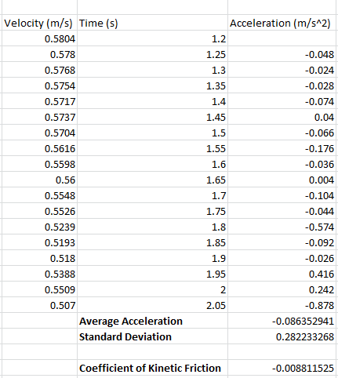Horizontal Tests:

Test 1:

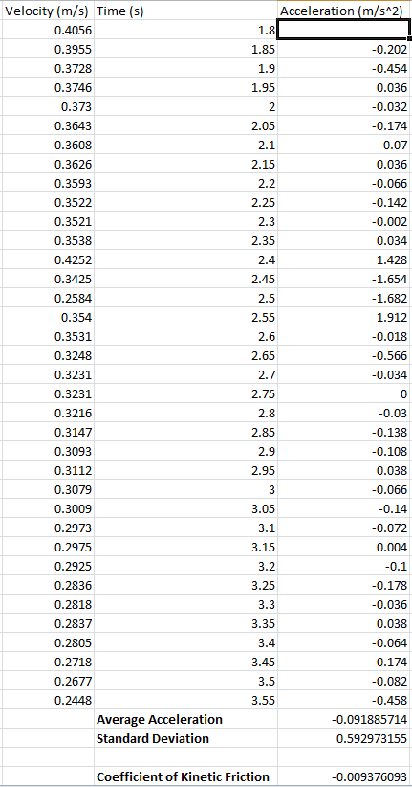Test 2:

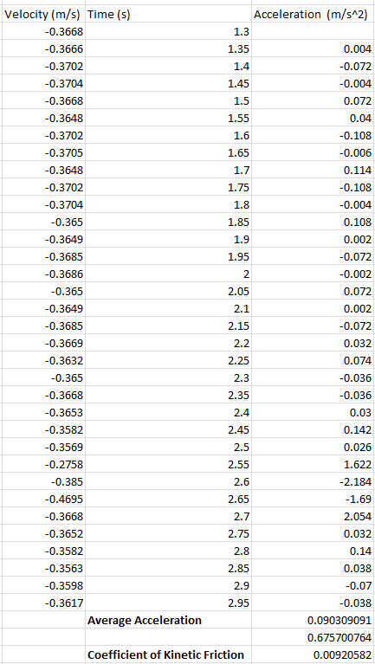Test 3:

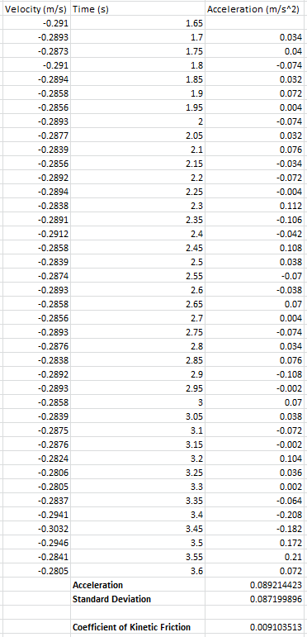

Test 4:

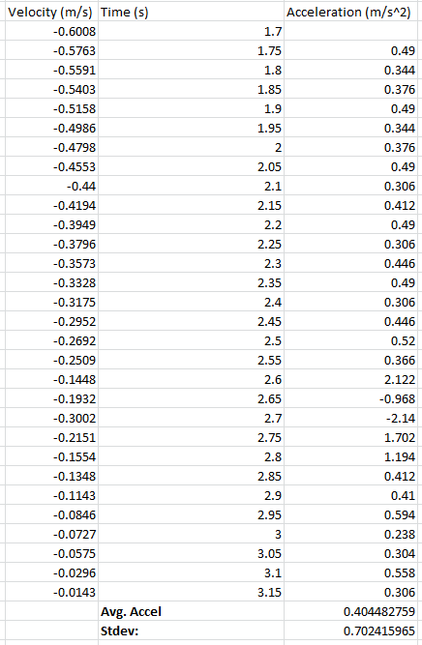Inclined Tests:

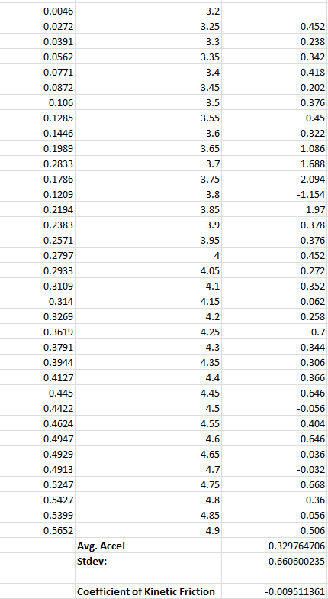Test 1:

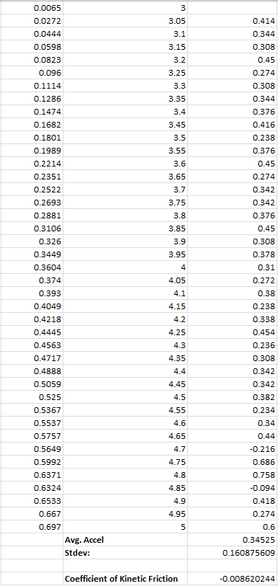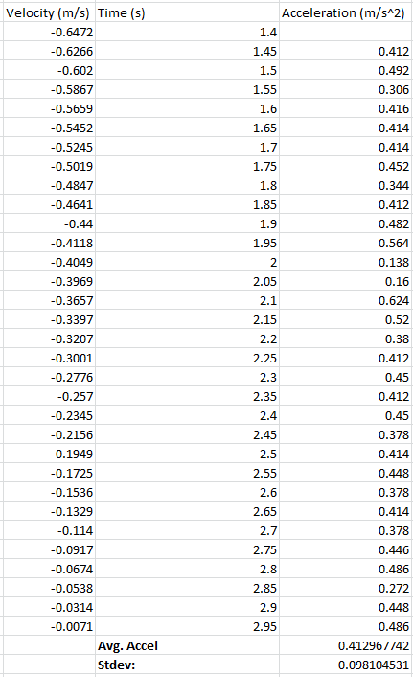Test 2:

Graph for Horizontal tests:

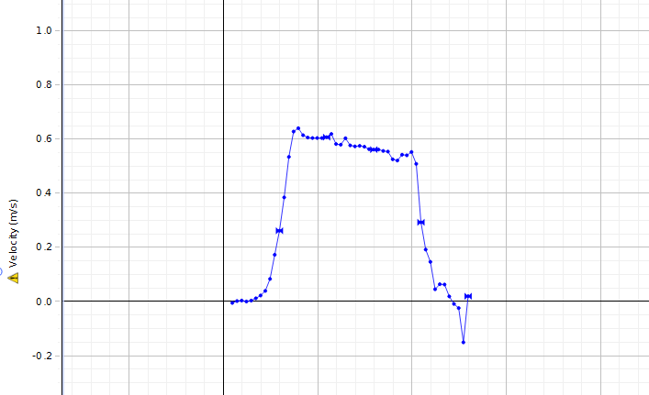

Graph for Angled tests:

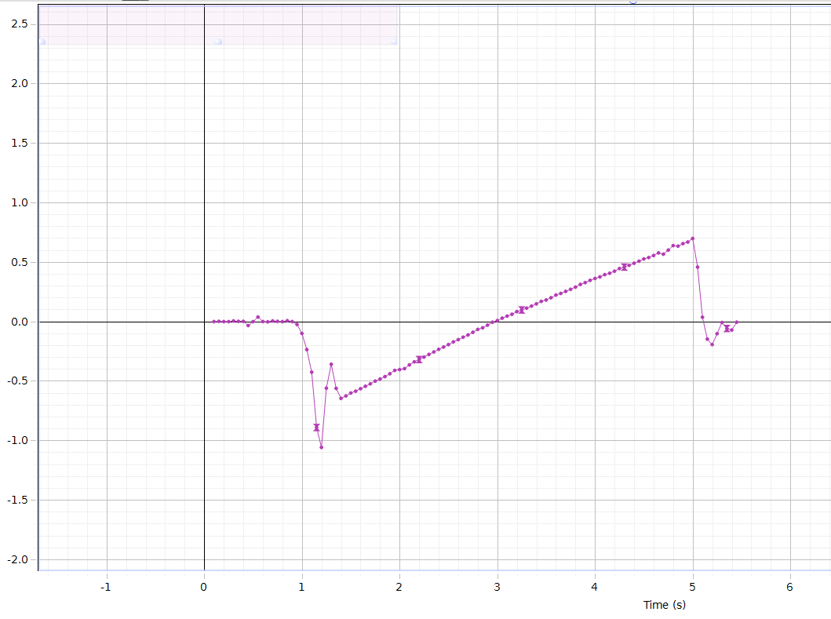

Measures of Frictional Forces and Coefficients of Static Frictions:

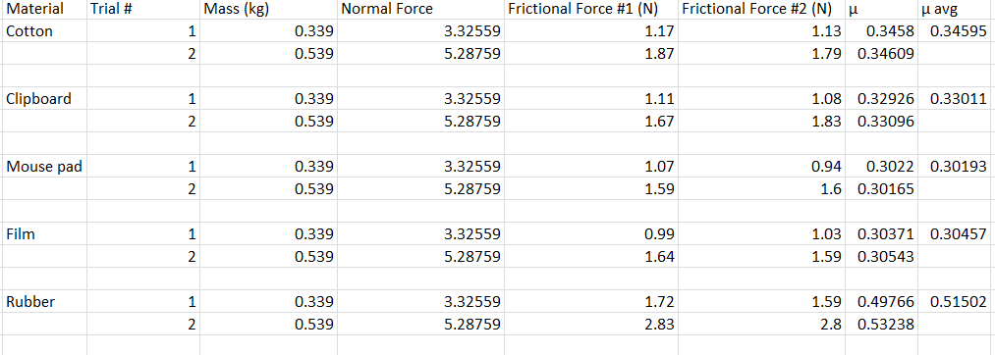

Graph of Frictional Force:

